**ABS Plastic Sheets: The Thermoforming Powerhouse for Modern Manufacturing**

ABS plastic sheets, or Acrylonitrile Butadiene Styrene sheets, have become quite well known in the manufacturing industry—and with good reason. They are tough, light, and extremely versatile. If you're in the business of building automobiles or designing appliances for the home, chances are you've used an [**Abs plastic sheet 4x8**](https://www.singhalglobal.com/products/abs-sheet-abs-plastic-sheets) along the way. Their thermoformability, in particular, has made them a favorite among engineers and product designers.

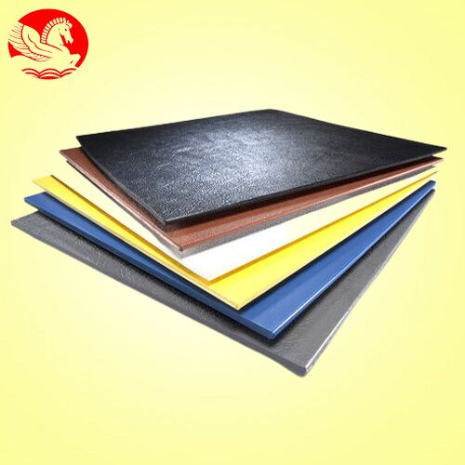

## **Learning About ABS Plastic Sheets**

Fundamentally, ABS is a thermoplastic polymer. What sets it apart is how the finest characteristics of its three building blocks—acrylonitrile, butadiene, and styrene—are brought together. What happens? A material that's tough, resilient, and a joy to work with.

## **Why ABS Reigns Supreme:**

* Impact Resistance: It's impact resistant, so it can withstand the rigors of being part of something that'll be subject to hits.
* Thermal Stability: ABS retains its form and strength at about 105°C—more than enough for most industrial applications.
* Chemical Resistance: Ordinary acids and alkalis won't affect it, so it suits a wide range of environments.
* Ease of Fabrication: ABS sheets are relatively easy to cut, drill, or machine, which quickens production.
* The Role of ABS Plastic Sheet 4x8 in Manufacturing

You’ll often hear professionals talk about the abs plastic sheet 4x8—it’s the standard 4-foot by 8-foot size and a favorite for good reason. It offers the right balance of size, manageability, and cost. You’ll find it across many sectors because of how adaptable it is.

## **Where It’s Commonly Used:**

* Automotive: For dashboards, interior panels, and trims—it’s sturdy and can look great too.
* Electronics: Applied to outer encasements for electronics. It's durable and provides a smooth finish.
* Construction: Consider wall panels, pipe fittings, and architectural details. ABS can withstand the stress.
* Furniture: Light but sturdy—it's a good choice for modular or custom furniture components.
* Thermoforming ABS Sheets

One of the major reasons ABS sheets are used so widely is the way they work in forming processes. The [**Thermoforming abs sheet**](https://www.singhalglobal.com/products/abs-sheet-abs-plastic-sheets) process is to heat up a plastic sheet until it's pliable and then shape it into a new form. ABS performs particularly well here.

**This is How It Goes Down:**

* Heat It Up: Sheets are heated to 140–150°C, so they become soft and flexible.
* Shape It: The sheet is draped over a mold and shaped using vacuum or pressure.
* Cool It Down: The fresh part is cooled so it retains its shape.
* Trim and Finish: Any excess plastic is trimmed off and finishing work is done.
* Why Thermoforming with ABS is an Intelligent Decision:
* Affordable: Tooling expenses are significantly less than injection molding.
* Quick Turnaround: Ideal for high-paced production lines.
* Design Friendly: Getting creative with designs and contours is a breeze.
* Custom Looks and Finishes

ABS plastic isn't only about performance—it can be pretty cool-looking too. It's available in various surface finishes, which makes it an excellent choice for products where the look counts as much as the function.

* Glossy: Smooth and shiny—ideal for exposed surfaces.
* Matte: Non-reflective and suited for rough applications.
* Textured: Provides grip and a professional appearance—often seen in tools and equipment.
* You can also choose from a variety of colors, thicknesses, and patterns to fit whatever project you’re working on.

**Finding ABS Sheets**

If you’re on the hunt for [**Abs sheets near me**,](https://www.singhalglobal.com/products/abs-sheet-abs-plastic-sheets) you’re in luck. There’s a wide network of suppliers that stock ABS sheets in various grades and sizes. Local distributors, plastic supply warehouses, or even specialized online retailers usually carry them. Just make sure to check the supplier’s reputation, product quality, and whether they offer custom cuts or finishes.

**Environmental Impact and Recycling**

On the sustainability front, ABS does have a couple of things in its favor. It's recyclable, and recycled ABS still has plenty of its strength and properties. It's not, however, biodegradable, so care should be taken in disposing of, or recycling it. A number of industries are now opting for recycled ABS in order to reduce waste and help with environmentally friendly production.

**Frequently Asked Questions**

**Q1: What is the typical size of an ABS plastic sheet?**

4 x 8-foot sheet is most commonly used. It's a convenient size and suitable for most general-purpose uses.

**Q2: May I use ABS sheets for outdoor projects?**

ABS has a poor resistance to UV light over time. For external use, use UV-stabilized types or apply a protective covering.

**Q3: Is ABS plastic safe for food applications?**

Not all ABS is food-safe. You’ll need to make sure it meets FDA or other safety standards before using it around food.

## **Conclusion**

In summary, ABS plastic sheets—particularly the abs plastic sheet 4x8—are a workhorse in modern manufacturing. They're dependable, easy to mold, and inexpensive. With their superior thermoforming capabilities, these sheets remain a favorite among industries requiring long-lasting, high-performance materials. Whether you're creating a car interior or constructing a custom piece of furniture, ABS sheets provide the versatility and functionality you require.